Dual MFA of Sweet and Skunky Morphs

Valerie Martin

11/4/2019

setwd("~/Desktop/Skypilot 2017")  
library(plyr)  
library(FactoMineR)  
  
stigma <- read.csv("Skypilot 2017 (MASTER) Tab2 08-12-19__Purity added.csv")  
cols <- c("Specimen.No.", "Year", "Era", "Species", "Scent.Morph", "Date", "Location", "Altitude..m.",  
 "Habitat..NMS.", "Corolla.Flare_1", "Sepal.Length_1", "Tube.Length_1", "Lobe.Length_1", "Lobe.Width_1",   
 "No.PVgrains_stigma", "No.PVgrains_off", "No.OtherGrains", "No.OtherTypes")  
stigma.sm <- subset(stigma, select = cols)  
  
#-----# subsets for analysis #-----#  
# subset to complete cases  
stigma.sm <- subset(stigma.sm, stigma.sm$Corolla.Flare_1 > 0 & stigma.sm$Sepal.Length_1 > 0 & stigma.sm$Tube.Length_1 > 0 &   
 stigma.sm$Lobe.Length_1 >0 & stigma.sm$Lobe.Width_1 >0) #eliminates all flowers without complete measurements  
# subset by morph  
stigma.sw <- subset(stigma.sm, Scent.Morph =="Sweet") #subset to sweet morph  
stigma.sk <- subset(stigma.sm, Scent.Morph =="Skunky") #subset to skunky morph  
nohab <- subset(stigma.sm, select = -c(stigma$Habitat..NMS.)) #subset to eliminate habitat  
stigma.new <- subset(stigma.sm, Era == "present") #selects for new era  
stigma.sw.new <- subset(stigma.sw, Era == "present") #selects for new sweet  
stigma.sw$No.Totalgrains <- stigma.sw$No.TotalPVgrains+stigma.sw$No.OtherGrains  
stigma.sk.new <- subset(stigma.sk, Era == "present") #selects for new skunky  
stigma.sk$No.Totalgrains <- stigma.sk$No.TotalPVgrains+stigma.sk$No.OtherGrains

**Dual Multiple Factor Analysis** DMFA is part of the multitable PCA family - it analyzes several sets of observations measured on the same set of variables, provides a set of common factor scores (compromise) and projects each of the original data sets onto the compromise to analyze commonalities and discrepancies

stigma.new.dmfa <- subset(stigma.sm, select = c("Scent.Morph", "Corolla.Flare_1", "Sepal.Length_1", "Tube.Length_1", "Lobe.Length_1", "Lobe.Width_1"))  
  
DMFA(stigma.new.dmfa, num.fact = 1, scale.unit = TRUE, ncp = 5,   
 quanti.sup = NULL, quali.sup = NULL, graph = TRUE, axes=c(1,2))

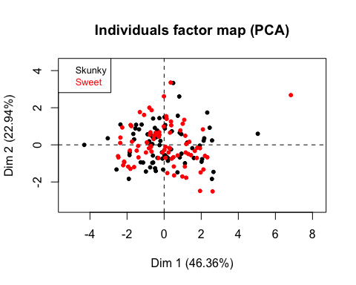

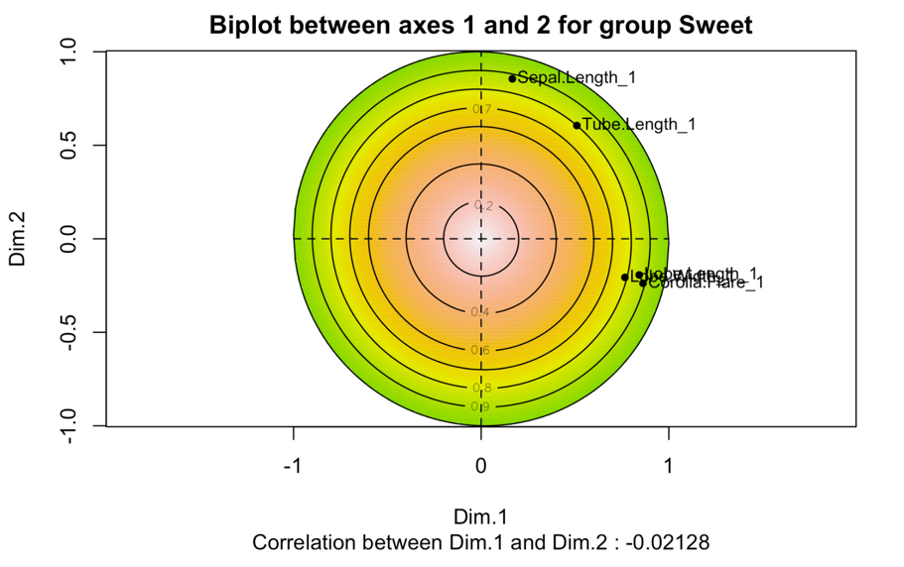

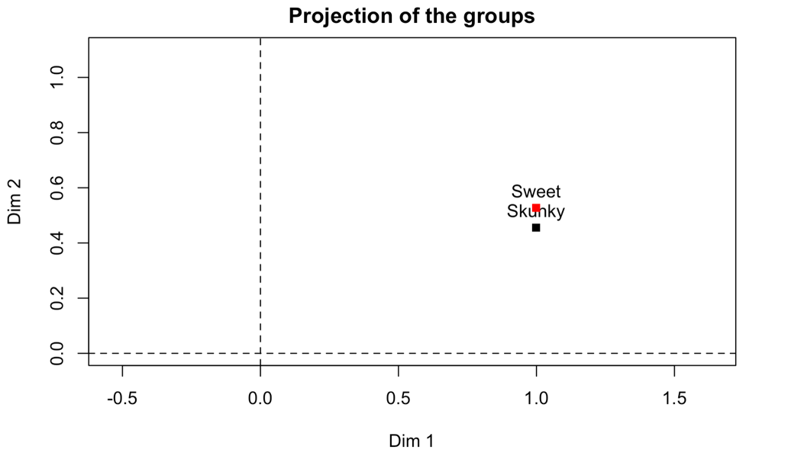

## $eig  
## eigenvalue percentage of variance cumulative percentage of variance  
## comp 1 2.3181867 46.363733 46.36373  
## comp 2 1.1467943 22.935887 69.29962  
## comp 3 0.7562746 15.125493 84.42511  
## comp 4 0.4145126 8.290251 92.71536  
## comp 5 0.3642318 7.284636 100.00000  
##   
## $var  
## $var$coord  
## Dim.1 Dim.2 Dim.3 Dim.4 Dim.5  
## Corolla.Flare_1 0.8388127 -0.2451080 0.01131479 0.1165816 0.47180085  
## Sepal.Length_1 0.1905959 0.8406357 0.48408276 -0.1092543 0.10359652  
## Tube.Length_1 0.5132659 0.5732942 -0.59568681 0.2128057 -0.08810681  
## Lobe.Length_1 0.8355232 -0.1133805 -0.12230536 -0.5041234 -0.14123368  
## Lobe.Width_1 0.7853103 -0.1962821 0.38988347 0.2992627 -0.32123782  
##   
## $var$cor  
## Dim.1 Dim.2 Dim.3 Dim.4 Dim.5  
## Corolla.Flare_1 0.8388127 -0.2451080 0.01131479 0.1165816 0.47180085  
## Sepal.Length_1 0.1905959 0.8406357 0.48408276 -0.1092543 0.10359652  
## Tube.Length_1 0.5132659 0.5732942 -0.59568681 0.2128057 -0.08810681  
## Lobe.Length_1 0.8355232 -0.1133805 -0.12230536 -0.5041234 -0.14123368  
## Lobe.Width_1 0.7853103 -0.1962821 0.38988347 0.2992627 -0.32123782  
##   
## $var$cos2  
## Dim.1 Dim.2 Dim.3 Dim.4 Dim.5  
## Corolla.Flare_1 0.70360672 0.06007794 0.0001280245 0.01359127 0.222596043  
## Sepal.Length_1 0.03632678 0.70666836 0.2343361193 0.01193650 0.010732240  
## Tube.Length_1 0.26344188 0.32866626 0.3548427727 0.04528628 0.007762809  
## Lobe.Length_1 0.69809896 0.01285513 0.0149586003 0.25414036 0.019946951  
## Lobe.Width_1 0.61671232 0.03852665 0.1520091224 0.08955817 0.103193737  
##   
## $var$contrib  
## Dim.1 Dim.2 Dim.3 Dim.4 Dim.5  
## Corolla.Flare_1 30.351599 5.238772 0.01692831 3.278856 61.113844  
## Sepal.Length_1 1.567035 61.621193 30.98558476 2.879646 2.946541  
## Tube.Length_1 11.364136 28.659564 46.91982969 10.925188 2.131283  
## Lobe.Length_1 30.114010 1.120962 1.97793229 61.310651 5.476445  
## Lobe.Width_1 26.603221 3.359508 20.09972496 21.605659 28.331887  
##   
##   
## $ind  
## $ind$coord  
## Dim.1 Dim.2 Dim.3 Dim.4 Dim.5  
## 1 -0.68311752 0.502566986 0.361105979 -0.857937396 -0.097963878  
## 2 -4.30626942 -0.003795812 0.693247003 -0.075126897 0.127963033  
## 3 0.81648573 2.605761526 0.085472715 -0.178266787 0.120011960  
## 4 -0.05215067 -1.334476912 0.461942399 0.367066745 -0.992635857  
## 5 2.16354243 0.352152815 -0.934663214 0.235736777 -1.073452427  
## 6 1.52103015 -0.178144773 -0.227398091 1.420195328 -0.595461907  
## 7 -0.50200127 0.913236237 0.609793505 -0.964596652 -0.196777939  
## 8 2.32369177 1.740302316 0.784441609 -0.463536360 -0.291926296  
## 9 -0.59395431 1.419631622 0.510992317 -0.224874190 -0.876610198  
## 10 -0.59504936 0.383428987 -1.254241701 -0.391607492 -0.835937938

##   
## $ind$cos2  
## Dim.1 Dim.2 Dim.3 Dim.4 Dim.5  
## 1 2.925200e-01 1.583261e-01 8.173989e-02 4.613982e-01 6.015845e-03  
## 2 9.736108e-01 7.564711e-07 2.523242e-02 2.963288e-04 8.597101e-04  
## 3 8.876664e-02 9.041113e-01 9.727642e-04 4.231491e-03 1.917793e-03  
## 4 8.725345e-04 5.713272e-01 6.846024e-02 4.322678e-02 3.161132e-01  
## 5 6.797339e-01 1.800820e-02 1.268582e-01 8.069800e-03 1.673300e-01  
## 6 4.851691e-01 6.655239e-03 1.084404e-02 4.229740e-01 7.435762e-02  
## 7 1.038331e-01 3.436312e-01 1.532117e-01 3.833697e-01 1.595435e-02  
## 8 5.778849e-01 3.241408e-01 6.585755e-02 2.299598e-02 9.120754e-03  
## 9 1.023071e-01 5.844549e-01 7.572310e-02 1.466489e-02 2.228500e-01  
## 10 1.209975e-01 5.023892e-02 5.375673e-01 5.240496e-02 2.387913e-01

##   
## $ind$contrib  
## Dim.1 Dim.2 Dim.3 Dim.4 Dim.5  
## 1 1.298706e-01 1.420923e-01 1.112393e-01 1.145623e+00 1.699896e-02  
## 2 5.160863e+00 8.105729e-06 4.099820e-01 8.784590e-03 2.900411e-02  
## 3 1.855313e-01 3.819901e+00 6.232234e-03 4.946198e-02 2.551171e-02  
## 4 7.569022e-04 1.001855e+00 1.820390e-01 2.097107e-01 1.745301e+00  
## 5 1.302719e+00 6.976620e-02 7.452450e-01 8.649386e-02 2.041061e+00  
## 6 6.438661e-01 1.785373e-02 4.411257e-02 3.139256e+00 6.280561e-01  
## 7 7.013415e-02 4.691903e-01 3.172155e-01 1.448178e+00 6.858723e-02  
## 8 1.502716e+00 1.703853e+00 5.249404e-01 3.344246e-01 1.509513e-01  
## 9 9.818067e-02 1.133794e+00 2.227499e-01 7.870636e-02 1.361142e+00  
## 10 9.854302e-02 8.270898e-02 1.341996e+00 2.386891e-01 1.237766e+00

##   
## $ind$dist  
## 1 2 3 4 5 6 7   
## 1.2630416 4.3642388 2.7404616 1.7655036 2.6241941 2.1836913 1.5578903   
## 8 9 10 11 12 13 14   
## 3.0567354 1.8569498 1.7106643 2.2268653 2.6936874 1.0260721 1.5344844   
## 15 16 17 18 19 20 21   
## 1.1159721 1.2693604 1.8778015 2.2830258 1.6920496 2.4927787 1.5869561   
##   
##   
## $svd  
## $svd$vs  
## [1] 1.5225592 1.0708848 0.8696405 0.6438265 0.6035162  
##   
## $svd$U  
## [,1] [,2] [,3] [,4] [,5]  
## [1,] -0.448663997 0.469300681 0.415235916 -1.332559911 -0.162321875  
## [2,] -2.828309919 -0.003544556 0.797165018 -0.116688107 0.212029167  
## [3,] 0.536258755 2.433278933 0.098285111 -0.276886373 0.198854586  
## [4,] -0.034251983 -1.246144179 0.531187758 0.570133009 -1.644754340  
## [5,] 1.420990632 0.328842842 -1.074769620 0.366149535 -1.778663874  
## [6,] 0.998995705 -0.166352876 -0.261485159 2.205866499 -0.986654420  
## [7,] -0.329708858 0.852786595 0.701201805 -1.498224503 -0.326052467  
## [8,] 1.526174943 1.625106872 0.902029733 -0.719970914 -0.483709145  
## [9,] -0.390102591 1.325662262 0.587590279 -0.349277618 -1.452504882  
## [10,] -0.390821808 0.358048757 -1.442253054 -0.608250027 -1.385112720

## $svd$V  
## [,1] [,2] [,3] [,4] [,5]  
## [1,] 0.5509229 -0.2288836 0.01301088 0.1810761 0.7817534  
## [2,] 0.1251812 0.7849917 0.55664697 -0.1696952 0.1716549  
## [3,] 0.3371073 0.5353463 -0.68498051 0.3305327 -0.1459891  
## [4,] 0.5487623 -0.1058755 -0.14063898 -0.7830112 -0.2340180  
## [5,] 0.5157831 -0.1832896 0.44832717 0.4648189 -0.5322771  
##   
##   
## $call  
## $call$row.w  
## [1] 0.006451613 0.006451613 0.006451613 0.006451613 0.006451613  
## [6] 0.006451613 0.006451613 0.006451613 0.006451613 0.006451613  
## [11] 0.006451613 0.006451613 0.006451613 0.006451613 0.006451613  
## [16] 0.006451613 0.006451613 0.006451613 0.006451613 0.006451613  
## [21] 0.006451613 0.006451613 0.006451613 0.006451613 0.006451613

##   
## $call$col.w  
## [1] 1 1 1 1 1  
##   
## $call$scale.unit  
## [1] TRUE  
##   
## $call$ncp  
## [1] 5  
##   
## $call$centre  
## [1] -2.515349e-17 1.214306e-16 -5.984796e-17 -7.302102e-17 2.335371e-16  
##   
## $call$ecart.type  
## [1] 0.9935274 0.9935274 0.9935274 0.9935274 0.9935274  
##   
## $call$X  
## Scent.Morph Corolla.Flare_1 Sepal.Length_1 Tube.Length_1 Lobe.Length_1  
## 1 Skunky -0.713960427 0.63464329 -0.474768845 0.214438614  
## 2 Skunky -2.261369617 -0.12064986 -1.959316488 -2.415597625  
## 3 Skunky -0.083400242 2.23160133 1.525300564 0.269891185  
## 4 Skunky -0.424047698 -1.02295872 -0.777104918 -0.007371671  
## 5 Skunky 0.300734124 -0.19599541 1.781123396 1.339333632  
## 6 Skunky 0.663125035 -0.41651896 1.122185800 -0.086589630  
## 7 Skunky -0.800934245 1.11611971 -0.385618464 0.341187348  
## 8 Skunky 0.576151216 2.10847568 1.060168144 1.402707999  
## 9 Skunky -1.362640158 1.20432913 0.261690821 -0.165807589  
## 10 Skunky -1.148829520 -0.54515770 0.850858554 0.309500165

## Lobe.Width_1  
## 1 -0.62513117  
## 2 -1.99960908  
## 3 -0.16383379  
## 4 1.11650180  
## 5 1.30478644  
## 6 1.68135573  
## 7 -0.49333192  
## 8 1.16357296  
## 9 0.02445085  
## 10 -0.67220233

##   
## $call$row.w.init  
## [1] 1 1 1 1 1 1 1 1 1 1 1 1 1 1 1 1 1 1 1 1 1 1 1 1 1 1 1 1 1 1 1 1 1 1

##   
## $call$call  
## PCA(X = X, ncp = ncp, quanti.sup = quanti.sup, quali.sup = 1,   
## graph = FALSE)  
##   
## $call$quali.sup  
## $call$quali.sup$quali.sup  
## Scent.Morph  
## 1 Skunky  
## 2 Skunky  
## 3 Skunky  
## 4 Skunky  
## 5 Skunky  
## 6 Skunky  
## 7 Skunky  
## 8 Skunky  
## 9 Skunky  
## 10 Skunky

##   
## $call$quali.sup$modalite  
## [1] 2  
##   
## $call$quali.sup$nombre  
## [1] 72 83  
##   
## $call$quali.sup$barycentre  
## Corolla.Flare_1 Sepal.Length_1 Tube.Length_1 Lobe.Length_1  
## Skunky 3.191891e-16 8.673617e-17 1.396452e-16 -3.833739e-16  
## Sweet -4.093947e-16 8.586881e-17 -2.029626e-16 1.969318e-16  
## Lobe.Width_1  
## Skunky 4.510281e-16  
## Sweet 1.908196e-17  
##   
## $call$quali.sup$numero  
## [1] 1  
##   
##   
##   
## $var.partiel  
## $var.partiel$Skunky  
## Dim.1 Dim.2 Dim.3 Dim.4 Dim.5  
## Corolla.Flare_1 0.8113089 -0.25460483 0.02969289 0.1963514 0.47927057  
## Sepal.Length_1 0.2189345 0.82396680 0.52287488 -0.2784381 0.06417962  
## Tube.Length_1 0.5170592 0.53410681 -0.61835547 0.2497194 -0.14820222  
## Lobe.Length_1 0.8277153 -0.01400797 -0.02575279 -0.5069926 -0.22039611  
## Lobe.Width_1 0.8074425 -0.18371978 0.35301050 0.2677825 -0.32290985  
##   
## $var.partiel$Sweet  
## Dim.1 Dim.2 Dim.3 Dim.4 Dim.5  
## Corolla.Flare_1 0.8625369 -0.2378156 -0.004847558 0.03854058 0.46559778  
## Sepal.Length_1 0.1661552 0.8551057 0.449993825 0.05682571 0.14097134  
## Tube.Length_1 0.5099961 0.6054683 -0.575784331 0.17733985 -0.03156522  
## Lobe.Length_1 0.8422602 -0.1932067 -0.207227428 -0.50335491 -0.06679767  
## Lobe.Width_1 0.7662248 -0.2066125 0.422334367 0.33146858 -0.32023529  
##   
##   
## $cor.dim.gr  
## $cor.dim.gr$Skunky  
## Dim.1 Dim.2 Dim.3 Dim.4 Dim.5  
## Dim.1 1.00000000 0.02664424 0.02718582 0.01145267 -0.04303209  
## Dim.2 0.02664424 1.00000000 0.01037385 -0.12203672 -0.05470400  
## Dim.3 0.02718582 0.01037385 1.00000000 -0.15068339 0.03387399  
## Dim.4 0.01145267 -0.12203672 -0.15068339 1.00000000 0.07190758  
## Dim.5 -0.04303209 -0.05470400 0.03387399 0.07190758 1.00000000  
##   
## $cor.dim.gr$Sweet  
## Dim.1 Dim.2 Dim.3 Dim.4 Dim.5  
## Dim.1 1.00000000 -0.021280021 -0.023815741 -0.01122869 0.04044170  
## Dim.2 -0.02128002 1.000000000 -0.008448598 0.11123359 0.04779463  
## Dim.3 -0.02381574 -0.008448598 1.000000000 0.15064817 -0.03246231  
## Dim.4 -0.01122869 0.111233585 0.150648166 1.00000000 -0.07712380  
## Dim.5 0.04044170 0.047794626 -0.032462309 -0.07712380 1.00000000  
##   
##   
## $Xc  
## $Xc$Skunky  
## Corolla.Flare_1 Sepal.Length_1 Tube.Length_1 Lobe.Length_1 Lobe.Width_1  
## 1 -0.71396043 0.63464329 -0.474768845 0.214438614 -0.62513117  
## 2 -2.26136962 -0.12064986 -1.959316488 -2.415597625 -1.99960908  
## 3 -0.08340024 2.23160133 1.525300564 0.269891185 -0.16383379  
## 4 -0.42404770 -1.02295872 -0.777104918 -0.007371671 1.11650180  
## 5 0.30073412 -0.19599541 1.781123396 1.339333632 1.30478644  
## 6 0.66312504 -0.41651896 1.122185800 -0.086589630 1.68135573  
## 7 -0.80093425 1.11611971 -0.385618464 0.341187348 -0.49333192  
## 8 0.57615122 2.10847568 1.060168144 1.402707999 1.16357296  
## 9 -1.36264016 1.20432913 0.261690821 -0.165807589 0.02445085  
## 10 -1.14882952 -0.54515770 0.850858554 0.309500165 -0.67220233

## attr(,"scaled:center")  
## Corolla.Flare_1 Sepal.Length_1 Tube.Length_1 Lobe.Length_1   
## 1.1570139 1.6166528 1.6204861 0.6909306   
## Lobe.Width_1   
## 0.6014028   
## attr(,"scaled:scale")  
## Corolla.Flare_1 Sepal.Length_1 Tube.Length_1 Lobe.Length_1   
## 0.2759451 0.5441596 0.2579910 0.1262340   
## Lobe.Width_1   
## 0.1062222   
##   
## $Xc$Sweet  
## Corolla.Flare_1 Sepal.Length_1 Tube.Length_1 Lobe.Length_1  
## 77 -0.743519077 1.58503867 0.386671029 -0.208379414  
## 78 -0.721007373 1.52444069 0.564154798 -0.454870977  
## 79 -0.859829545 2.34630076 2.323559114 -0.406942062  
## 80 -0.297036956 -0.76502665 0.328795887 -0.694515553  
## 81 0.791028716 -0.85971099 -0.983040665 0.401002506  
## 82 0.033134696 1.06427480 -0.141921935 -0.235767365  
## 83 -1.602715763 0.70826168 -0.604923070 -1.262815546  
## 85 -1.122466087 -0.99226907 -0.057038393 -1.516154097  
## 86 -0.259517450 -0.08329940 0.714630167 0.401002506  
## 87 -1.351335073 -0.05489410 -2.233143732 -0.879384225  
## 88 -0.015640662 1.03776318 -0.307830675 -0.893078201

## Lobe.Width_1  
## 77 0.59506546  
## 78 -0.78550884  
## 79 -0.05644151  
## 80 -0.54507174  
## 81 1.47149746  
## 82 0.66486978  
## 83 -1.07248215  
## 85 -0.46751139  
## 86 -1.08799422  
## 87 -0.89409333  
## 88 0.40892061

## attr(,"scaled:center")  
## Corolla.Flare_1 Sepal.Length_1 Tube.Length_1 Lobe.Length_1   
## 1.1891687 1.6239880 1.6347831 0.6714337   
## Lobe.Width_1   
## 0.6002771   
## attr(,"scaled:scale")  
## Corolla.Flare_1 Sepal.Length_1 Tube.Length_1 Lobe.Length_1   
## 0.2665280 0.5280704 0.2591786 0.1460496   
## Lobe.Width_1   
## 0.1289319   
##   
##   
## $group  
## $group$coord  
## Dim.1 Dim.2 Dim.3 Dim.4 Dim.5  
## Skunky 2.308466 1.053027 0.7689370 0.4716885 0.3978812  
## Sweet 2.326603 1.227983 0.7453109 0.3650066 0.3350963  
##   
## $group$coord.n  
## Dim.1 Dim.2 Dim.3 Dim.4 Dim.5  
## Skunky 0.9986250 0.4555316 0.3326363 0.2040489 0.1721204  
## Sweet 0.9989211 0.5272314 0.3199973 0.1567146 0.1438727  
##   
## $group$cos2  
## Dim.1 Dim.2 Dim.3 Dim.4 Dim.5  
## Skunky 71.46999 14.87154 7.929727 2.983921 2.123164  
## Sweet 69.78515 19.44031 7.161323 1.717591 1.447630  
##   
##   
## $Cov  
## $Cov$Skunky  
## Corolla.Flare_1 Sepal.Length_1 Tube.Length_1 Lobe.Length_1  
## Corolla.Flare_1 1.000000000 -0.007282429 0.2582782 0.5241062  
## Sepal.Length_1 -0.007282429 1.000000000 0.1816034 0.1687980  
## Tube.Length_1 0.258278171 0.181603371 1.0000000 0.3369235  
## Lobe.Length_1 0.524106237 0.168797968 0.3369235 1.0000000  
## Lobe.Width_1 0.597120974 0.111717869 0.1911230 0.5533072  
## Lobe.Width_1  
## Corolla.Flare_1 0.5971210  
## Sepal.Length_1 0.1117179  
## Tube.Length_1 0.1911230  
## Lobe.Length_1 0.5533072  
## Lobe.Width_1 1.0000000  
##   
## $Cov$Sweet  
## Corolla.Flare_1 Sepal.Length_1 Tube.Length_1 Lobe.Length_1  
## Corolla.Flare_1 1.000000000 -0.002193703 0.2736473 0.66916164  
## Sepal.Length_1 -0.002193703 1.000000000 0.3260491 -0.06186254  
## Tube.Length_1 0.273647313 0.326049104 1.0000000 0.34614213  
## Lobe.Length_1 0.669161641 -0.061862540 0.3461421 1.00000000  
## Lobe.Width_1 0.592376678 0.103728919 0.1149257 0.50089868  
## Lobe.Width_1  
## Corolla.Flare_1 0.5923767  
## Sepal.Length_1 0.1037289  
## Tube.Length_1 0.1149257  
## Lobe.Length_1 0.5008987  
## Lobe.Width_1 1.0000000  
##   
##   
## attr(,"class")  
## [1] "DMFA" "list"

**How to interpret this analysis?**

The default DMFA function prints everything – I abbreviated all of the tables to the first 10 or so individuals.

Still learning how PCA works as well as how multiple factor analysis and the closely related dual-multiple factor analysis work. Curious if your familiarity with PCAs will help with this task.

**Resources that I’ve been using:**

–CRAN document on DMFA function:  <https://rdrr.io/cran/FactoMineR/man/DMFA.html#heading-6>

–YouTube channel of Francois Husson (who developed the R function and collaborated on multiple books/papers concerning multivariate analyses): <https://www.youtube.com/channel/UCyz4M1pwJBNfjMFaUCHCNUQ>

–Abdi, H., Williams, L. J., & Valentin, D. (2013). Multiple factor analysis: principal component analysis for multitable and multiblock data sets. Wiley Interdisciplinary reviews: computational statistics, 5(2), 149-179. <https://personal.utdallas.edu/~herve/abdi-WiresCS-mfa-2013.pdf>

–Lê, S., & Pagès, J. (2010). DMFA: Dual Multiple Factor Analysis. Communications in Statistics - Theory and Methods, 39(3), 483–492. <https://doi.org/10.1080/03610920903140114> <https://www.tandfonline.com/doi/citedby/10.1080/03610920903140114?scroll=top&needAccess=true>